Lab Title: Descriptive Statistics Calculator
Course: CS 1410 – Object Oriented Programming

Objectives: array data structure, two-dimensional array data structure, array initialization, array copy and sort, array iteration

Overview

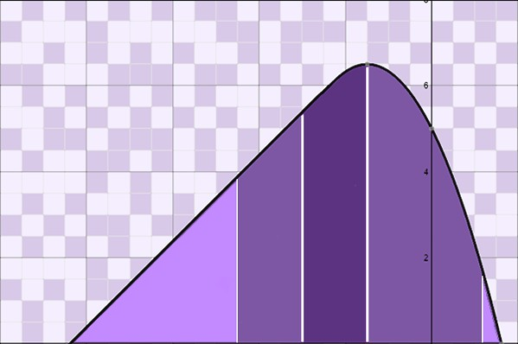
In this project, you will program a complete calculator that computes common descriptive statistics. The calculator will accept a user-provided set of data and calculate the statistics: mean, median, mode, range, variance, and standard deviation. A strong understanding of these statistics is not required for this project, as each of the features, uses, and calculations will be outlined and described as needed. You will use one and two-dimensional array data structures to store and manipulate the data.

The project is divided into three parts. In Part 1, you will collect and store user data into an array data structure. In addition, you will organize the data by printing it, making a copy, and sorting the copy. (This will facilitate the computations in the subsequent parts). In Part 2, you will program and output the primary statistics: mean, median, range, variance, and standard deviation. A thorough description of each of these statistics, with worked examples, is included. Finally, in Part 3 you will use a two-dimensional array to determine whether the dataset has none, one, or multiple modes. You will complete the project by testing your computations with various datasets.

Part 1: User Input and Setup

In this first part of the project, you will collect data from the user, store the data into an array, provide a function to display the data onto the console window, copy the data, and sort the copy. These latter steps will facilitate calculations in Part 2. Follow the steps as provided.

Collect user data. The first step in the calculator is to collect the dataset from the user. To do this, you will need to define an array to store the dataset, and then prompt the user for input values. Two potential approaches to this problem are provided. You may choose whichever you deem appropriate.

Approach 1 (Indeterminate): As the size of the array must be defined before compilation, you can overestimate the size needed by a healthy margin upon initialization and then keep track of the current location in the array. A sample session using this indeterminate approach is provided:
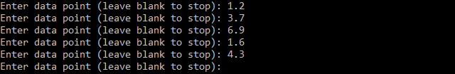

Approach 2 (Determinate): Alternatively, you can request that the user specify the number of data points up front and then use a for loop to collect the data. (With this approach, the array will need to be defined on the heap using the new keyword). A sample session of the determinate approach is provided:
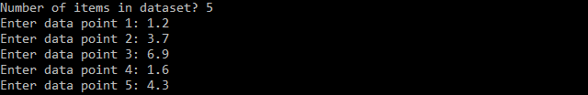

Print user data. You will need to provide some means of displaying the dataset, and perhaps displaying interim datasets for testing. Define a function to display all initialized items in an array with formatted output. Use any style of formatted output you deem appropriate. Take care not to display any uninitialized values. One sample output is provided.

Copy user data. To simplify some of the statistics in Part 2, we will need to modify the data by putting it in a sorted order. At the same time, we will want to retain the dataset in the order as provided by the calculator user (in case the order, as provided, is somehow meaningful or useful).

Make a second array and use iteration to duplicate the values from the first array into the second array. You may perform this operation using a function if desired. Please ensure that the second array represents a copy of the data, not a copy of the reference to the original array.

Sort the copy of the user data. Include a function that can sort an array, given the array and its size. An understanding of sorting algorithms is not required for this project. As such, the code is provided for you; simply incorporate it into your project and use it to sort the copy of the array created in the previous step. (Code on next page).

The following function represents a simple selection sort algorithm. It is noted that the C++ library has faster and more efficient sorting algorithms available for use. For this project, use the selection sort algorithm as provided below. As you include it in your project, see if you can understand how the selection sort algorithm works.
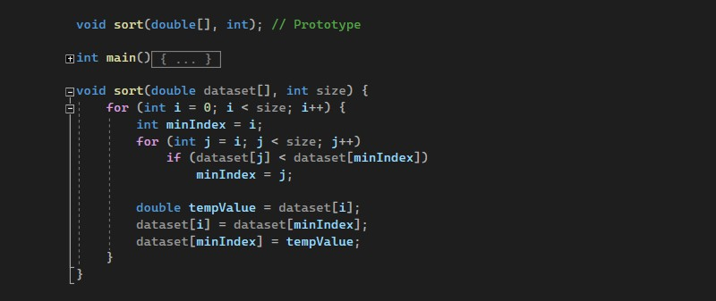

At this point, your program should be able to accept data points as input, store the data points into an array, make a copy of the array, and sort the copy. Display both the original dataset and the sorted copy to test the program. A sample session is provided.
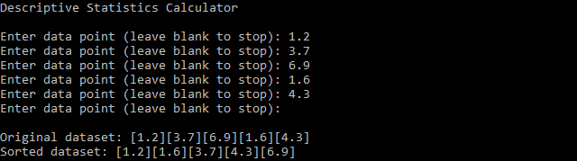

Part 2: Measures of Central Tendency and Dispersion

In this part of the project, you will use the dataset retrieved in Part 1 to calculate two common measures of central tendency: mean and median, as well as three common measures of dispersion: range, sample variance, and sample standard deviation. Measures of central tendency are used to summarize the typicality of a set of data. Measures of dispersion are used to determine the degree to which items in a dataset are spread out.

Follow the steps provided to program the measures of central tendency and dispersion. A description of each of the statistics, as well as some hints and references for programming, is provided.

Compute the arithmetic mean (average). The arithmetic mean is the average of all the values in a set of data. It is computed by adding all the items in the dataset, and then dividing by the number of items (or the size). Figure 1 includes the formula for, and an example of, the arithmetic mean. Take note of the ∑ symbol in the equation, which simply refers to the summation of a set of values or computation; in computer programming, this is often completed using a for loop.
Figure 1
The mean is calculated by adding all items in a dataset and dividing by the size.

The mean is expressed by the following formula, where Σ refers to a summation in the formula, 𝑥 refers to any given item in the dataset, and 𝑛 is the total number of items.
∑ 𝑥
𝑛
Sample mean calculation:
d[0] + d[1] + d[2] + d[3] + d[4] =
85 + 90 + 83 + 92 + 100 = 450
𝑛 = size = 5
450
= 90
5

Dataset d[]
size | 5
index | 0 | 1 | 2 | 3 | 4
value | 85 | 90 | 83 | 92 | 100

Compute the median. The median is the middlemost number of a dataset, or the average of the two middle numbers. It is found by placing all the items in ascending or descending order and finding the middlemost item(s). For a dataset with an odd number of items, the median is the middle number. For a dataset with an even number of items, take the average of the two middle numbers. Figure 2 shows examples of the median for both odd and even numbered datasets.

Figure 2

The median is the middlemost number of a dataset for a dataset with an odd number of items; for an even numbered dataset, it is the average of the two middlemost items.
For an ordered dataset with an odd number of items, the median is the value found in the middle position, calculated by dividing size by 2. The formula is provided.

𝑛 𝑡ℎ
() 2

Sample odd median calculation:

Dataset d[]
size | 5
index | 0 | 1 | 2 | 3 | 4
value | 16 | 17 | 19 | 20 | 23

5
n = size = 5 index = (2) = int(2.5) = 2 𝑑[2] = 19

For an ordered dataset with an even number of items, the median is calculated by adding the two middlemost items, as found using the formula below, and divided by 2.

𝑛 𝑡ℎ 𝑛 𝑡ℎ
(2 − 1) + (2)

2
Sample even median calculation:

Dataset d[]
size | 6
index | 0 | 1 | 2 | 3 | 4 | 5
value | 16 | 17 | 19 | 20 | 23 | 25

𝑛 = 𝑠𝑖𝑧𝑒 = 6

6
𝑖𝑛𝑑𝑒𝑥₁ = (
6
− 1) + 𝑖𝑛𝑑𝑒𝑥₂ = ()
𝑑[2] + 𝑑[3]
19 + 20 39

2 2 =
2 2
= = = 19.5
2 2

Compute the range. The range is the difference between the largest and smallest items in the data set. It is the least descriptive measure of dispersion, and the least reliable, because it depends on only two values within a dataset. The range is calculated by finding the maximum and minimum values in the dataset and subtracting. If the dataset is in ascending order, it can be found by subtracting the value found at the first index from the value found at the last index.
Figure 3

The range is the difference between the largest and smallest items in a dataset.
Sample range calculation:
2
3
5
7
9
𝑑[4] – 𝑑[0] = 9 – 2 = 7

Dataset d[]
size | 5
index | 0 | 1 | 2 | 3 | 4
value | 2 | 3 | 5 | 7 | 9

Compute the sample variance. The sample variance is a measure of dispersion that uses all values in a dataset to determine the spread. The variance is reported in points squared, which has an arbitrary meaning and provides for limited interpretation. The formula for the sample variance is provided in Figure 4. Again, as suggested by the Σ, this computation will require a loop.

Figure 4

The sample variance uses all items in a dataset to determine the spread. The sample variance is expressed by the formula and definitions provided.

𝑠² =
∑(𝑥 − 𝑥̅)²

𝑛 − 1
𝑠2 | Sample variance
𝑥 | A given value in the dataset
𝑥̅ | Mean of the dataset
𝑛 | Number of items in the dataset
Σ | Sum of all corresponding calculations

Dataset d[]
size | 5
index | 0 | 1 | 2 | 3 | 4
value | 85 | 90 | 83 | 92 | 100

𝑥̅ =
∑ 𝑥

𝑛
85 + 90 + 83 + 92 + 100
= =
5
450

5
= 90

(𝑥 − 𝑥̅)
(−7)² = 49
(0)² = 0
d[0] = 85
85 − 90 = −5
(−5)² = 25
(𝑥 − 𝑥̅)²
𝑛 − 1
25
∑(𝑥 − 𝑥̅)²
𝑛 − 1
25
= = 6.25
d[1] = 90
1
2
5 − 1 4
0
6.25
5 − 1 4
0
= = 0
0
d[2] = 83
𝑥 − 𝑥̅
83 − 90 = −7
d[4] = 100 100 − 90 = 10
12.25
d[3] = 92
92 − 90 = 2
(2)² = 4
5 − 1 4
4
5 − 1 4
4
= = 1
90 − 90 = 0
49 49
= = 12.25
(10)² = 100
5 − 1 4
100 100
= = 25
+
25
index
𝑠² = 44.5

Compute the sample standard deviation. The sample standard deviation also uses all values in a dataset to determine the spread. The value is comparable to average deviation about the mean. It is easier to quantify than the variance because the unit of measurement reflects the dataset. A low standard deviation indicates low variability among the data points; a high standard deviation indicates data points that are spread out over a larger range. The formula for the sample standard deviation is shown in Figure 5.
Figure 5
The standard deviation reflects the spread in common units of measurement.
The sample standard deviation is expressed by either of the following formulas and their respective definitions. Observe that the sample standard deviation can be calculated by square rooting the sample variance.
∑(𝑥 − 𝑥̅)²
𝑠 = √
𝑛 − 1
𝑠 = √𝑠²
𝑠² = 44.5 (See Figure 4)

𝑠 = √𝑠²
𝑠 = √44.5
𝑠 = 6.67083

𝑠 | Standard deviation
𝑠2 | Sample variance
𝑥 | A given value in the dataset
𝑥̅ | Mean of the dataset
𝑛 | Number of items in the dataset
Σ | Sum of all corresponding calculations

Dataset d[]
size | 5
index | 0 | 1 | 2 | 3 | 4
value | 85 | 90 | 83 | 92 | 100

At this point in the project, your program should accept a dataset via user input, copy and sort the dataset, display the dataset, and then compute and display the mean, median, range, variance, and standard deviation. Continuing the example from Part 1, sample output is provided.
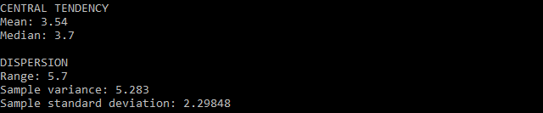

Part 3: Determine the Mode(s)

In this part of the project, you will write an algorithm to calculate the mode of a dataset. The mode is the most recurring item within a set of data. If all items in the set occur with equal frequency, there is no mode. If two sets of values are the most frequent, the set is said to be bimodal. If three values have equal quantities of most occurrences, the set is trimodal, and so-on. There is no set formula for determining the mode, although one algorithm is described in this section.
First, an algorithm used to calculate the mode should account for all the following scenarios:
- The dataset contains no mode, wherein all values occur in equal amounts.
- The dataset contains one mode, wherein one value occurs more frequently than all others.
- The dataset contains more than one mode, wherein more than one value shares the most occurring status.
Examples of these are depicted in Figure 6.
Figure 6
The mode algorithm should account for no mode, one mode, or several modes.
Dataset with no mode:
Mode: [None]
Dataset with one mode:
Mode: [2]
Dataset with three modes:
Mode: [1][2][3]

Dataset d[]
1 | 2 | 3 | 4 | 5

Dataset d[]
1 | 2 | 2 | 2 | 3

Dataset d[]
1 | 1 | 2 | 2 | 3 | 3 | 4 | 5 | 6

Although there may be several approaches for determining the mode, for this project you will use a two-dimensional array with the dimensions: 2 × size of dataset. The first row of the two- dimensional array will be used to store each unique value dataset. The second row will be used to store a count of repeat values. A visual example of this is provided in Figure 7.
Figure 7

A two-dimensional array can be used to keep a count of values.
Mode: [4]

 | index | [0] | [1] | [2] | [3] | [4]
value | [0] | 1 | 2 | 3 | 4 | 6
frequency | [1] | 1 | 1 | 2 | 3 | 1

After the entire dataset has been scanned and recorded into the two-dimensional array, you will need to check the frequency row to determine the mode(s). Start by finding the highest value in the frequency row. If the highest value occurs only once, that is the mode. If the highest value occurs more than once, then there are multiple modes to be displayed. If the highest value occurs equally throughout the row, then no mode is found. Proper completion of the mode may require iterating through the two-dimensional array more than once. Refer to the pseudocode provided in Figure 8 on the next page, if needed.

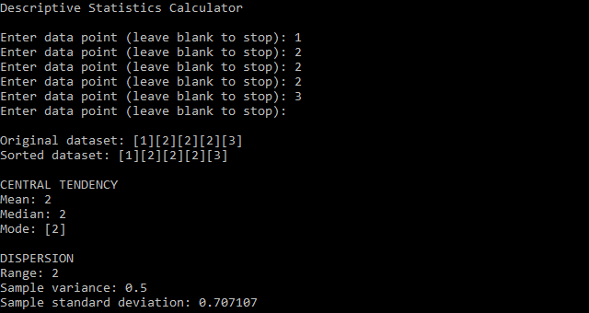

Figure 8

Pseudocode for calculating the mode(s) using a two-dimensional array. Compute the mode for the following dataset:
Dataset d[]
1 | 2 | 2 | 2 | 3

Define a two-dimensional array (mode), with 2 rows and a length at least the size of the original. You will also need a variable to track the “filled” portion of the array.

mode[], filled = 0
mode[0]
mode[1]

Iterate through the original dataset (or the sorted copy of the dataset). For each value of the dataset:
- Search the first row of the mode array (employ a linear search) to find the index of the current value.
  - If the current value exists in the first row of the mode array, increase the corresponding index of the second row of the mode array by 1.
  - If the current value does not exist in the mode array, append the value to the end of the first row of the mode array (and increase the variable used to track the filled index).

mode[], filled = 3
mode[0] | 1 | 2 | 3
mode[1] | 0 | 2 | 0
Find the highest value in the second row of the mode array. Perform the following checks (each may require iteration).
- If all values in the second row of the mode array are the same, there is no mode.
- Otherwise, each value in the first row of the mode array, with a value in the second row of the mode array that matches the highest value, is a mode. These should be printed.

Mode: 2

Test the project with various datasets, ensuring that the values for all measures of central tendency and dispersion are correct.
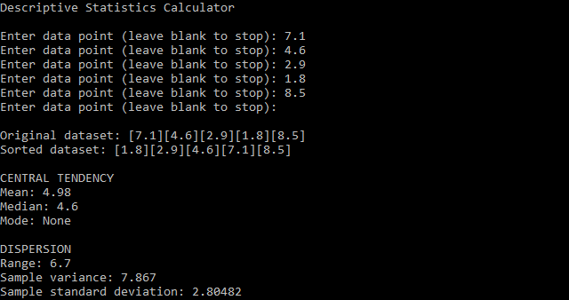

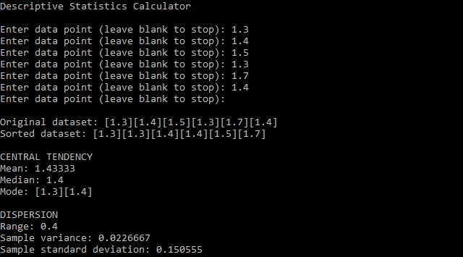

Submit the completed .cpp file online for grading. A grade rubric is provided on the next page.

